Application for Design Patent

1. **Name and Address of the applicant/s**

**Inventor #1**

Name: Ms. SAUMYA EZHIL

Nationality: Indian

Address: Sb 1073, Sobha Hillview apartments Kanakapura road Bangalore.

Pin code: 560109

**Inventor #2**

Name: Ms. ADRIJA SARKAR

Nationality: Indian

Address: AE-182, Sector 1, Saltlake City, Kolkata, West Bengal.

Pin code: 700064

**Inventor #3**

Name: Ms. ALEKYA RAMANI NALAGANDLA

Nationality: Indian

Address: FF1, Jai Venkata Sai towers, Prasadampadu, Currency Nagar, Vijayawada, Andhra Pradesh.

Pin code: 521108

**Inventor #4**

Name: Ms. KRIMAN KAUR

Nationality: Indian

Address: 1-D-8 Sukhadia Nagar, Sri Ganganagar, Rajasthan

Pin code: 335001

1. **Name/ Title of the Article**

AUTONOMOUS UNDERWATER ROBOTS FOR SURVEILLANCE IN NAVAL DEFENSE

1. **The use and purpose of the Article (in 2-3 lines)**

An underwater rover to navigate and monitor underwater environments, detect foreign objects or vessels, and communicate findings back to a central command.

1. **Article View from different angles such as Front, Rear, Top, Bottom, Left Side, Right Side, and Perspective views:**

This design is novel on the basis of the tools and equipment that are used for the process which are not seen to be claimed anywhere.

No claim is made by virtue of this registration in respect of any mechanical or other action of any mechanism whatever or in respect of any mode or principle of construction of the Article.

No claim is made by virtue of this registration to any right to the exclusive use of the words, letters, numbers, or trademarks appearing in the representation.

**FRONT VIEW**

The novelty resides in the shape and configuration of the “Integrated Self Power Generation & Sensor Fusion autonomous underwater rover” as illustrated.

No claim is made by virtue of this registration in respect of any mechanical or other action of any mechanism whatever or in respect of any mode or principle of construction of the Article.

No claim is made by virtue of this registration to any right to the exclusive use of the words, letters, numbers, or trademarks appearing in the representation.

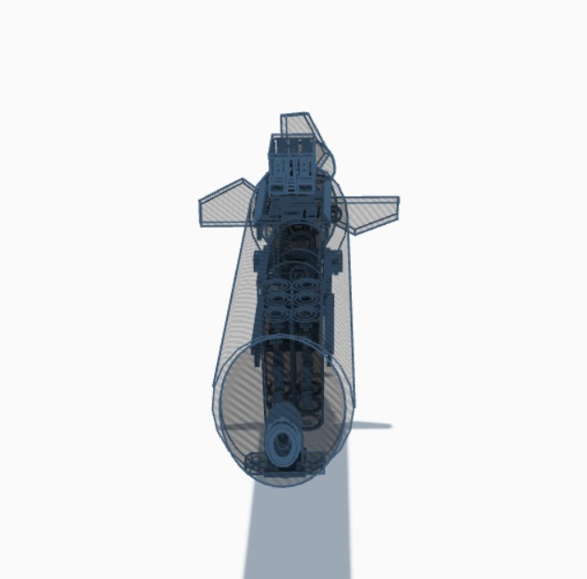

**REAR VIEW**

The novelty resides in the shape and configuration of the “Integrated Self Power Generation & Sensor Fusion autonomous underwater rover” as illustrated.

No claim is made by virtue of this registration in respect of any mechanical or other action of any mechanism whatever or in respect of any mode or principle of construction of the Article.

No claim is made by virtue of this registration to any right to the exclusive use of the words, letters, numbers, or trademarks appearing in the representation.

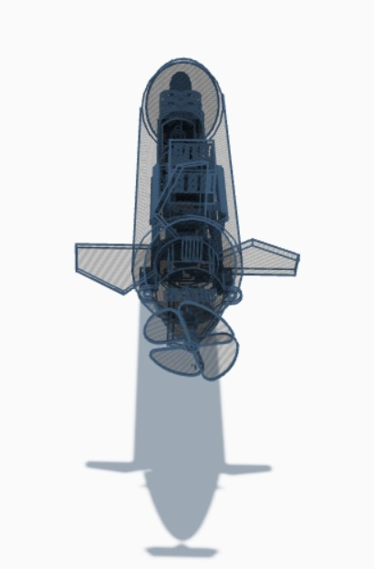

**LEFT SIDE VIEW**

The novelty resides in the shape and configuration of the “Integrated Self Power Generation & Sensor Fusion autonomous underwater rover” as illustrated.

No claim is made by virtue of this registration in respect of any mechanical or other action of any mechanism whatever or in respect of any mode or principle of construction of the Article.

No claim is made by virtue of this registration to any right to the exclusive use of the words, letters, numbers, or trademarks appearing in the representation.

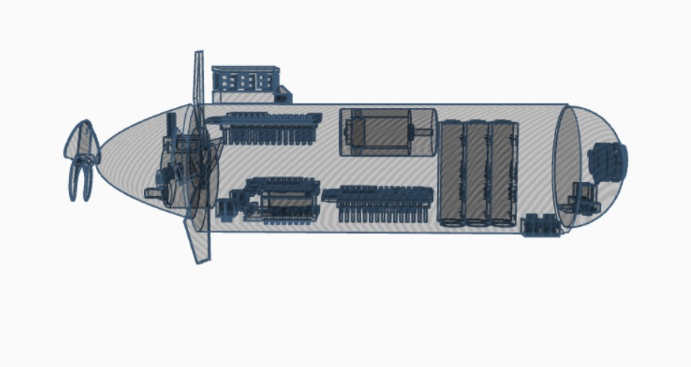

**RIGHT SIDE VIEW**

The novelty resides in the shape and configuration of the “Integrated Self Power Generation & Sensor Fusion autonomous underwater rover” as illustrated.

No claim is made by virtue of this registration in respect of any mechanical or other action of any mechanism whatever or in respect of any mode or principle of construction of the Article.

No claim is made by virtue of this registration to any right to the exclusive use of the words, letters, numbers, or trademarks appearing in the representation.

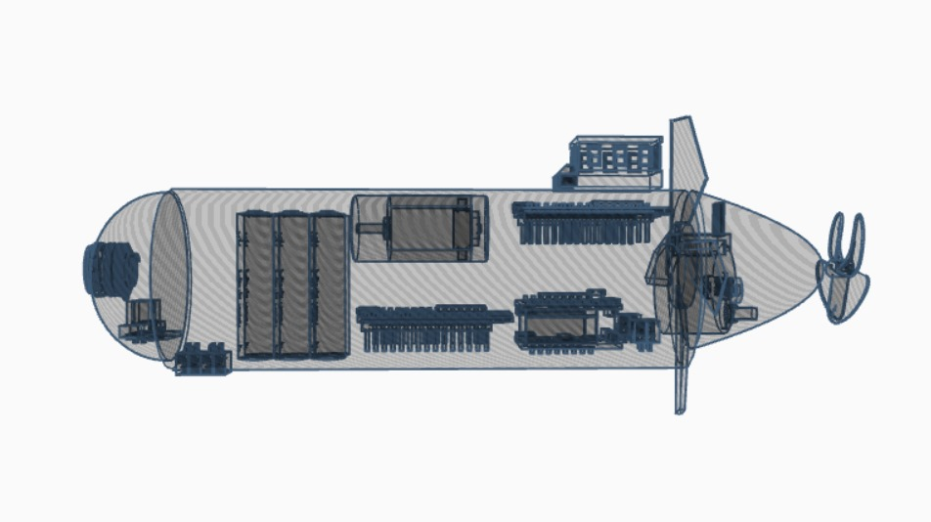

**TOP VIEW**

The novelty resides in the shape and configuration of the “Integrated Self Power Generation & Sensor Fusion autonomous underwater rover” as illustrated.

No claim is made by virtue of this registration in respect of any mechanical or other action of any mechanism whatever or in respect of any mode or principle of construction of the Article.

No claim is made by virtue of this registration to any right to the exclusive use of the words, letters, numbers, or trademarks appearing in the representation.

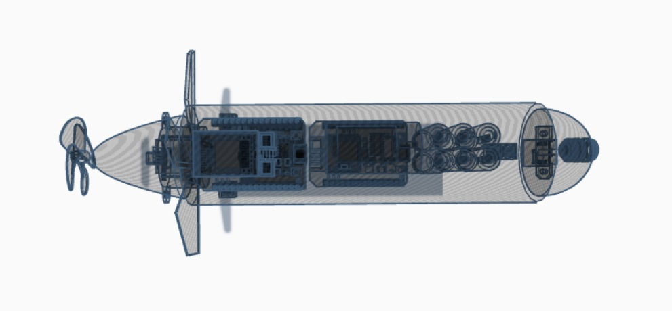

**BOTTOM VIEW**

The novelty resides in the shape and configuration of the “Integrated Self Power Generation & Sensor Fusion autonomous underwater rover” as illustrated.

No claim is made by virtue of this registration in respect of any mechanical or other action of any mechanism whatever or in respect of any mode or principle of construction of the Article.

No claim is made by virtue of this registration to any right to the exclusive use of the words, letters, numbers, or trademarks appearing in the representation.

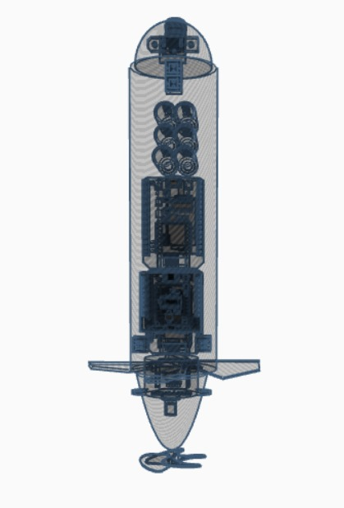

**PERSPECTIVE VIEW**

The novelty resides in the shape and configuration of the “Integrated Self Power Generation & Sensor Fusion autonomous underwater rover” as illustrated.

No claim is made by virtue of this registration in respect of any mechanical or other action of any mechanism whatever or in respect of any mode or principle of construction of the Article.

No claim is made by virtue of this registration to any right to the exclusive use of the words, letters, numbers, or trademarks appearing in the representation.

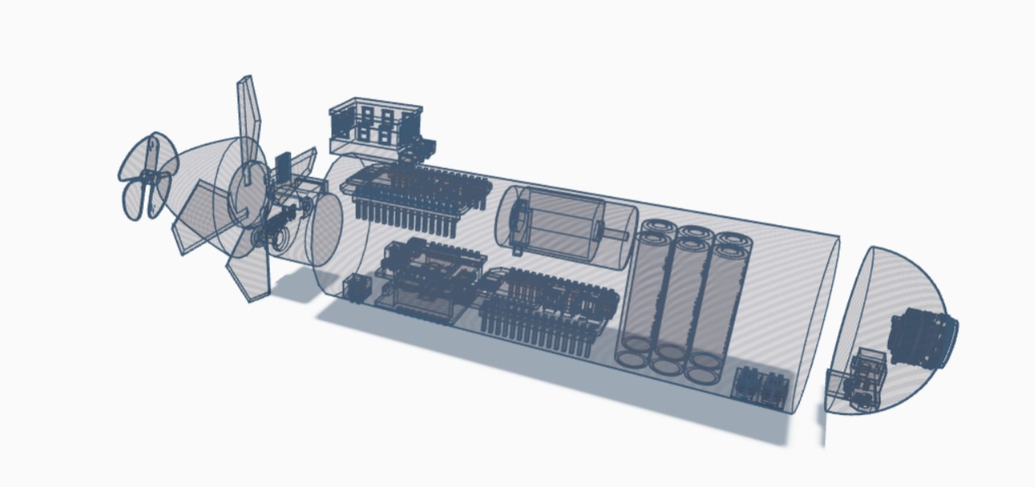

**ANOTHER PERSPECTIVE VIEW**

The novelty resides in the shape and configuration of the “Integrated Self Power Generation & Sensor Fusion autonomous underwater rover” as illustrated.

No claim is made by virtue of this registration in respect of any mechanical or other action of any mechanism whatever or in respect of any mode or principle of construction of the Article.

No claim is made by virtue of this registration to any right to the exclusive use of the words, letters, numbers, or trademarks appearing in the representation.

